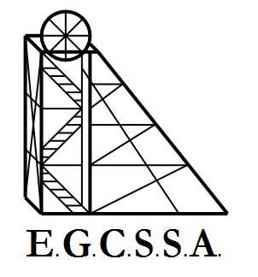


RULES, GUIDELINES & PROCEDURES

- All games will be played at school ovals (this is to reduce travel costs & increase the atmosphere and crowd surrounding the games)
- The host school is responsible for the following:
- Providing Goal umpires - 2 goal umpires (these can be students if need be).
- The Goldfields Clontaf Academy will usually send field umpires, but host schools need to have a teacher or responsible adult to umpire if no GCA Umpires are available.
- Supplying the scoresheets (print from Website), match football, goal flags and timer.
- Marking out the playing field (including putting up goal posts if necessary)
- OPTIONAL (invite classes out the watch the match and support their school )
- Games will be 12-minute quarters with 3 minutes break after the 1st quarter and 3rd quarter, with a 5-minute break at half time.
- Games commence at 1.15pm SHARP and conclude at 2.15 pm.
- An Eagles Cup booklet and football will be distributed to you by registering online. However the main rules to be noted are as follows:
- No sling or dumping tackles
- No soccering of the ball
- Only 15 players per team on the ground at one time
- No boundary throws-ins (a free kick will be awarded against the team which touched the ball last before it went out)
- Points will be deducted if a player misbehaves or is sent off.

- Scorecards are for individual team use only. As per Eagles Cup guidelines there will be no record of results or ladder.

. . . . . . . . . . . . . . . . . . . . . . . . . . . . . .

