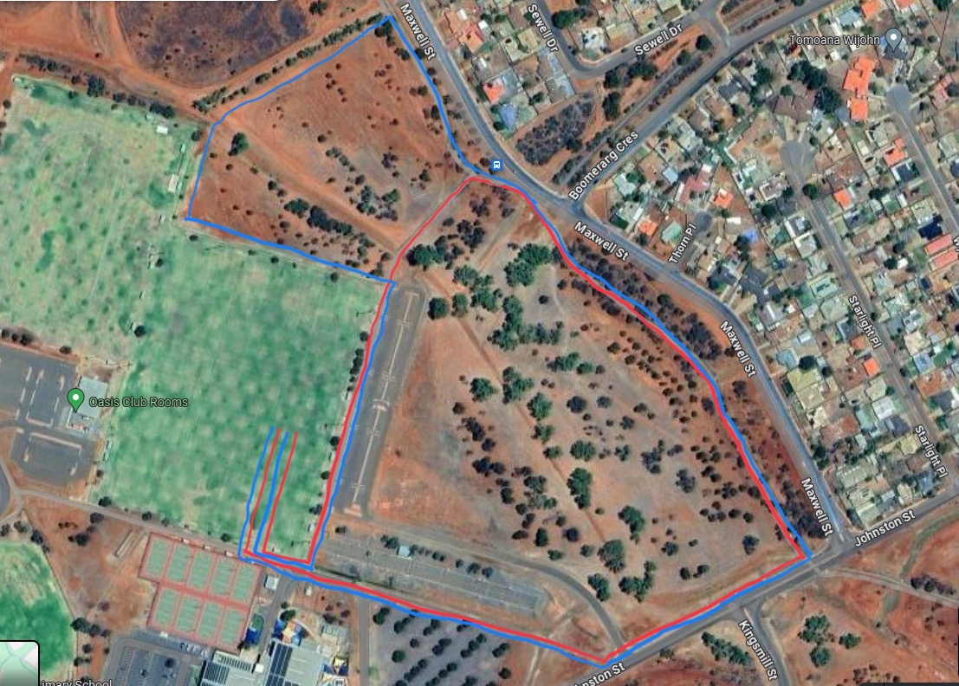

**1**

**2**

**3**

**4**

**5**

**6\***

**7\***

**Red** - Year 3&4 - 1500m  
**Blue** – Year 5&6 - 2000m

**STATION SCHOOL STATION SCHOOL**

**1 East Kal 5 Hannans**

**2 North Kal 6 O’Connor**

**3 St Mary’s 7 Boulder**

**4 CAPS - K**



2025

MC900241885[1]CROSS COUNTRY

**Date** **Friday 1st August 2025**

**Venue** **Oasis Playing Fields**

**E.G.C.S.S.A. INTERSCHOOL CROSS COUNTRY (Year 3-6)**

**Organising School (202)** Kambalda Primary School

**Coordinator: Laura Hodges** Laura.hodges@education.wa.edu.au

**Program**: ***Please note that times below are approximates only**

9.00 am All course marshals and place judges to be at Oasis Playing Fields

9.30 am Students are walked around the course

10.00 am Year 3 Girls

10.15 am Year 3 Boys

10.30am Year 4 Girls

10.45 am Year 4 Boys

11:00 am Year 5 Girls

11.15 am Year 5 Boys

11.30am Year 6 Girls

11.45 am Year 6 Boys

**Presentations** 12:05 pm

**Finish Time** 12.25pm

**Guidelines**

Each school nominates a maximum of three students in each event (a fourth runner may attend as a reserve. This runner will assume the registration number of an injured runner if needed)

The Year 3 and Year 4 course is 1500m

The Year 5 and Year 6 course is 2000m

**Awards**

1st Place – Champion medal

2nd Place – Runner up medal

3rd Place – Ribbon

4th Place – Ribbon

The first twelve place getters receive championship points – from 12 points to 1 point.

There will be **Two Overall Champion School Shields** awarded   
(Pool A & Pool B)

(*ie: School with the most points* *in each pool* will receive a shield.)

**At the end of each race, runners who are given a place card   
(1st – 12th) must report to the recorders table.**

**Important Information for schools:**

Each school should bring a shelter for sun and rain protection (Carnival will go ahead in light rain)

Schools should remind athletes to bring a dry change of clothes in case of rain.

Each school should bring their own first-aid kits and ice packs

Spectators must stay well back from the track, finish straight or pathways during races.

Team Nominations – Please email your team nominations to the coordinator listed above.

Registration Numbers – please write the student's registration number on top of their right hand *(Alternatively runners may carry their number with them on a card)*

**OFFICIAL DUTIES**

**Starter** St Joseph’s

**Start /Finish Marshall** St Mary’s

**Announcer** North Kalgoorlie P.S.

**Recorders (2)** Kalgoorlie P.S.

**Presentations** North Kalgoorlie P.S.

**Chief Judge** Hannans P.S.

(Watches/Videos finish line, and can help decide close results or resolve disputes)

**Timekeeper** O’Connor P.S

**Place Judges** (4) Boulder P.S 1st 2nd

G.B.C. 3rd 4th

South Kalg P.S 5th 6th 7th 8th

Kam West. 9th 10th 11th 12th

(One representative from 4 **different** schools to be place judges)

**Course Marshals** One representative from the following schools.

Each person with a first aid kit. Map on the back.

**(Teacher, Parent, Education Assistant only) NO Students please**